

Digital Logic Design

LAB – 03

Universal Logic Gates

* Student ID: k224779
* Student name: Muhammad Bilal

**Lab Task#1:**

((A.B + C.D)’ +B’)’.C

**Lab Task#2:**

(A’B + C)’

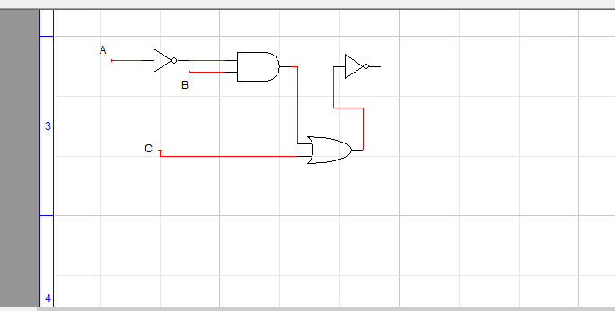

|  |  |  |  |
| --- | --- | --- | --- |
| A | B | C | y |
| 0 | 0 | 0 | 1 |
| 0 | 0 | 1 | 0 |
| 0 | 1 | 0 | 0 |
| 0 | 1 | 1 | 0 |
| 1 | 0 | 0 | 1 |
| 1 | 0 | 1 | 0 |
| 1 | 1 | 0 | 1 |
| 1 | 1 | 1 | 0 |

**Lab Task#3:**

1.

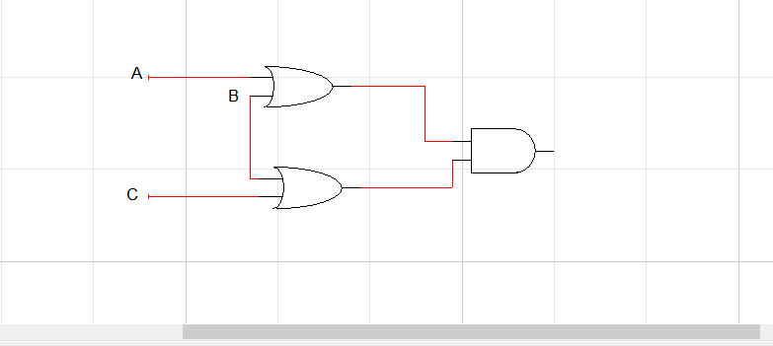

2.

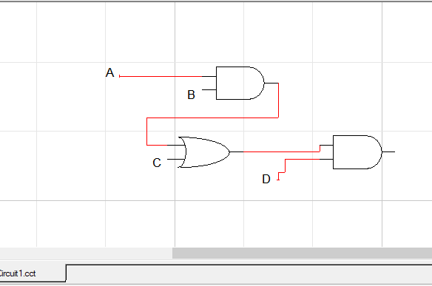

3.

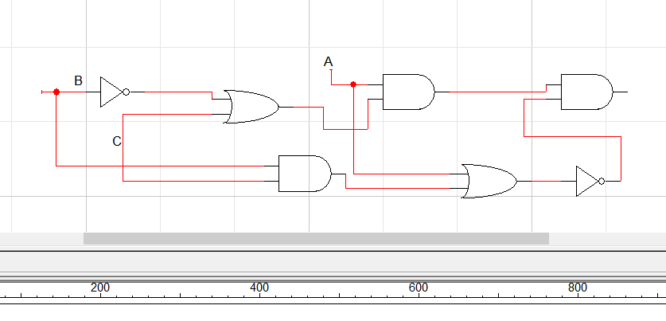

4.

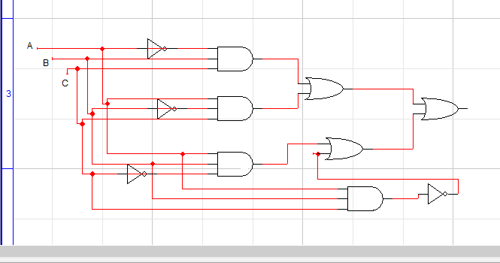

5.

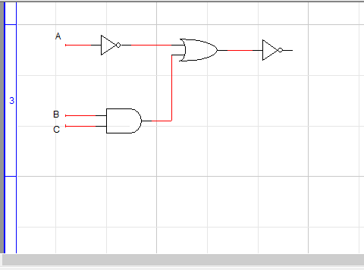

**Lab Task#4:**

